**BIT302**

**SOFTWARE ENGINEERING**

**ASSIGNMENT 3**



**Project Title:**

**Information System for MHS**

**Prepared By:**

**Leader: I Kadek Bagus Paradhita Utama**

**(**[**E1700866/bagusparadhita@gmail.com**](mailto:E1700866/bagusparadhita@gmail.com)**)**

**Member: I Nengah Wahyudi Setiawan**

**(**[**E1700868/nengahwahyudi90@gmail.com**](mailto:E1700868/nengahwahyudi90@gmail.com)**)**

**Table of Contents**

**Problems faced in Iteration 1 and the solutions 2**

**Architectural Design 3**

**Design Class Diagram 3**

**ERD 4**

**Site Map 5**

**Generic User Experience/Wireframe 6**

**System Sequence Diagram + Contracts 10**

**Database Design (Data Dictionary) 15**

**Identification of The Use Cases to be Developed by Member 16**

**Test Objectives 16**

**Test Plan & Method & Automated Testing Tool 16**

**Test Cases 17**

**Unit and Integration Testing 17**

**System Testing 25**

**Test Analysis Report 33**

**Conclusion/Review 33**

**Update Gantt Chart/Trello 36**

**GitHub 40**

**Reference 41**

**Problems faced in Iteration 1 and the solutions**

In the previous assignment, we have not tried all the existing use cases. This time we will try to resolve use cases that were not resolved in the previous assignments. As for some of the fundamental causes of our problem, first, the world is currently experiencing an outbreak of the corona virus (COVID-19) which makes it difficult for us to schedule meetings to discuss the execution of this task. Secondly, due to the limited ability and knowledge we have about this task, we cannot perform this task to the fullest, especially because it is difficult to communicate with the teammate, because we are separated by distance and the teammate is not always active on social media to be contacted, so in the process of doing this task, we must do it independently with a very minimal level of discussion when compared to when we can meet face to face, even though this is actually a group assignment. Third, we also don't fully have a lot of free time at home, even though the government has actually recommended self-isolation, because we also have internal affairs in our family as a result of the coronavirus outbreak (COVID-19) which has various negative impacts on the lives of people including in our family which makes us have many burdens in mind.

However, in this assignment we have tried our best, despite the limitations that are actually known and felt by all people in all parts of the world. We try to push ourselves harder to exceed our limits as humans in the midst of this epidemic by speeding up our work until the wee hours of the morning and reducing our sleep due to a long period of self-isolation and other activities we have to do in the morning and afternoon. Trying to have discussions online, although sometimes having to wait for a very slow response from the teammate and because of each other's activities, so much time is wasted and workmanship becomes ineffective.

**Architectural Design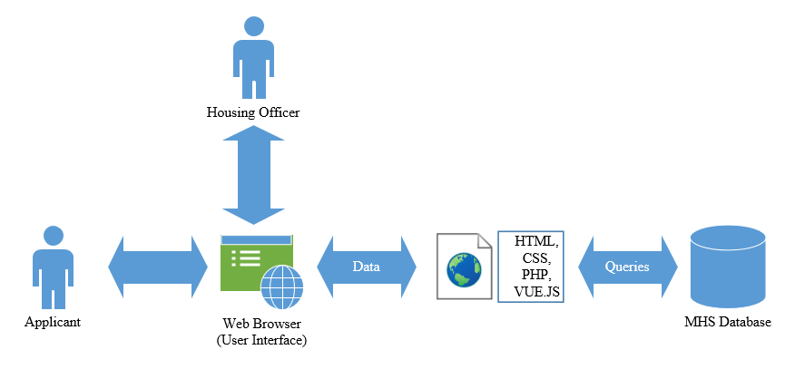Design Class Diagram**

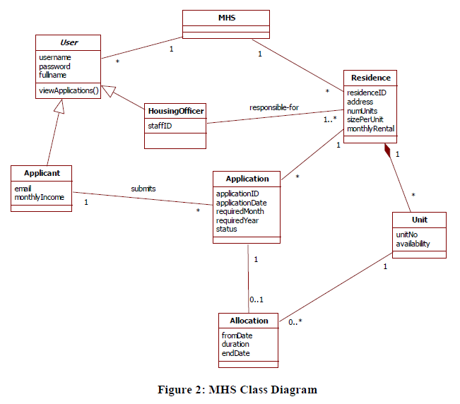

**ERD**

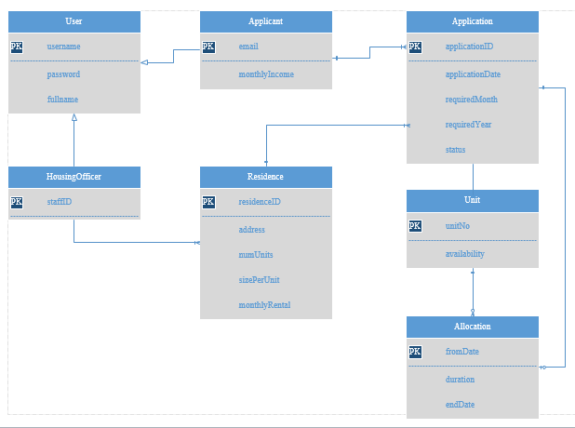

**Site Map**

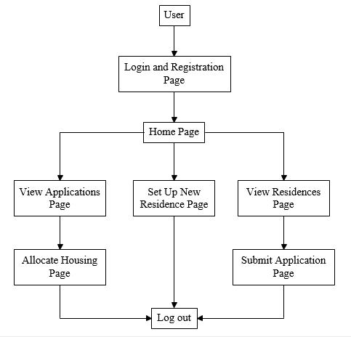

**Generic User Experience/Wireframe**

1. **Login and Registration Page**

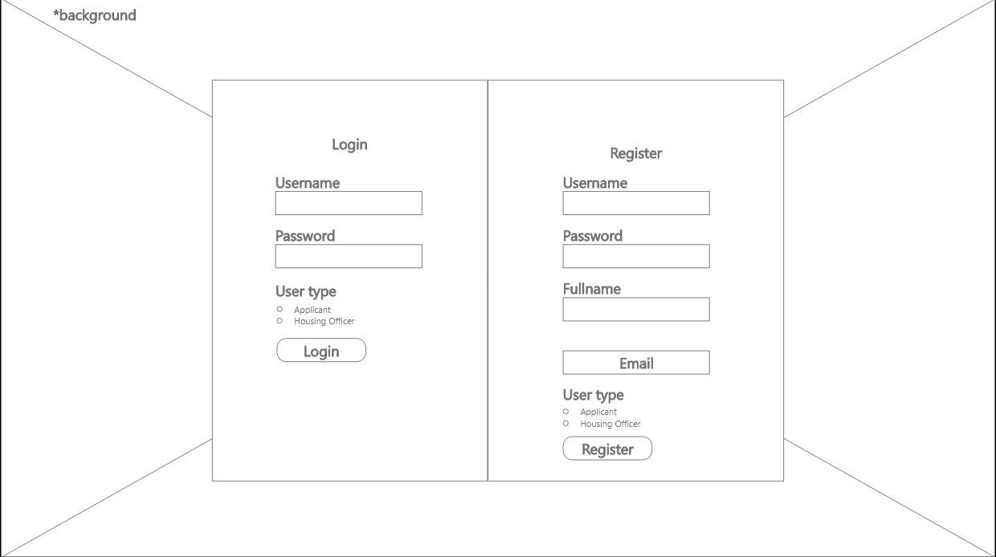

1. **Home Page (Housing Officer)**

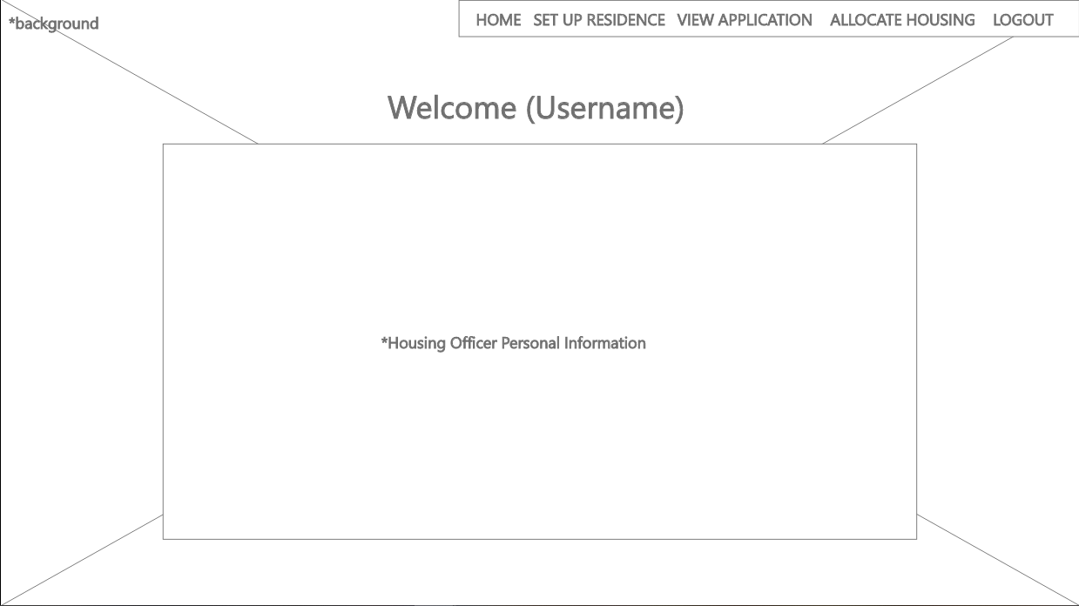

1. **Home Page (Applicant)**

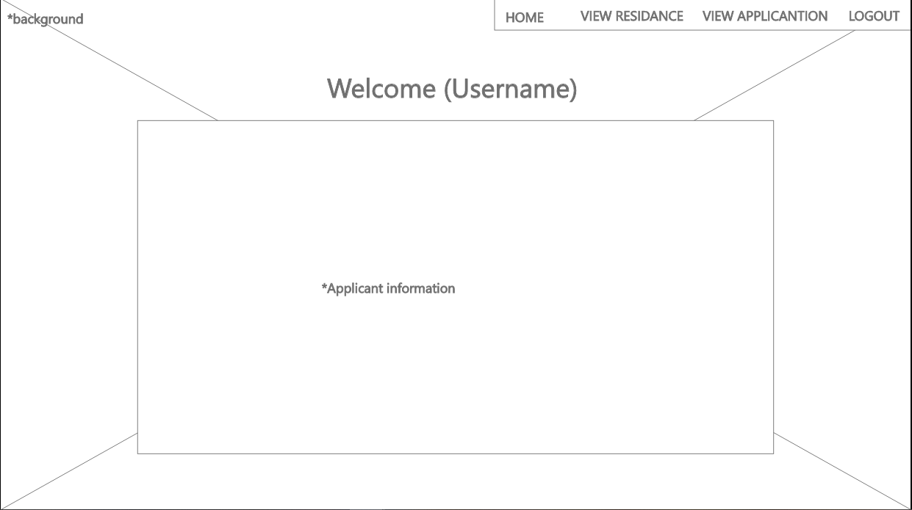

1. **Set Up New Residence Page**

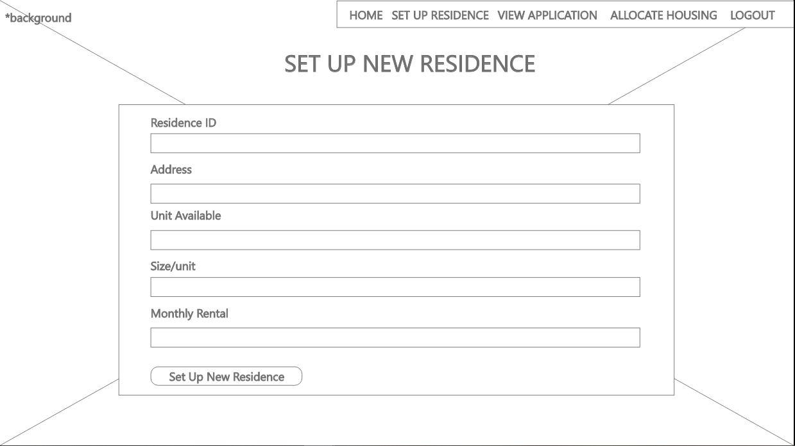

1. **View Residences Page**

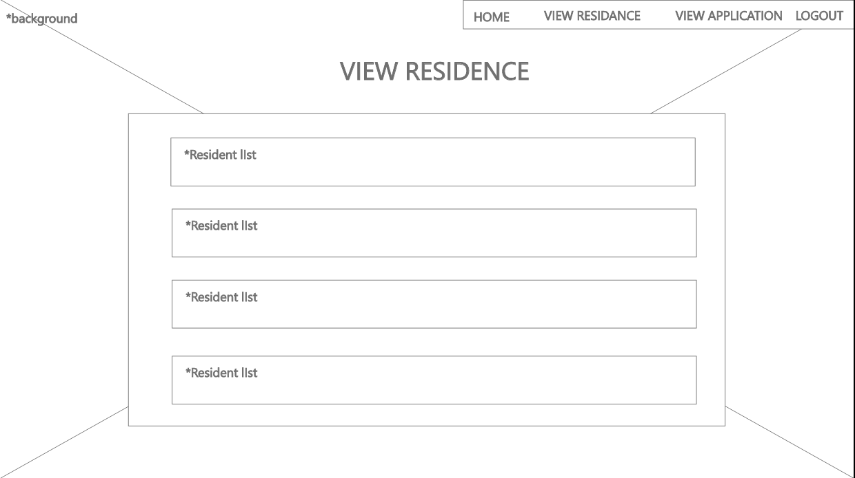

1. **Submit Application Page**

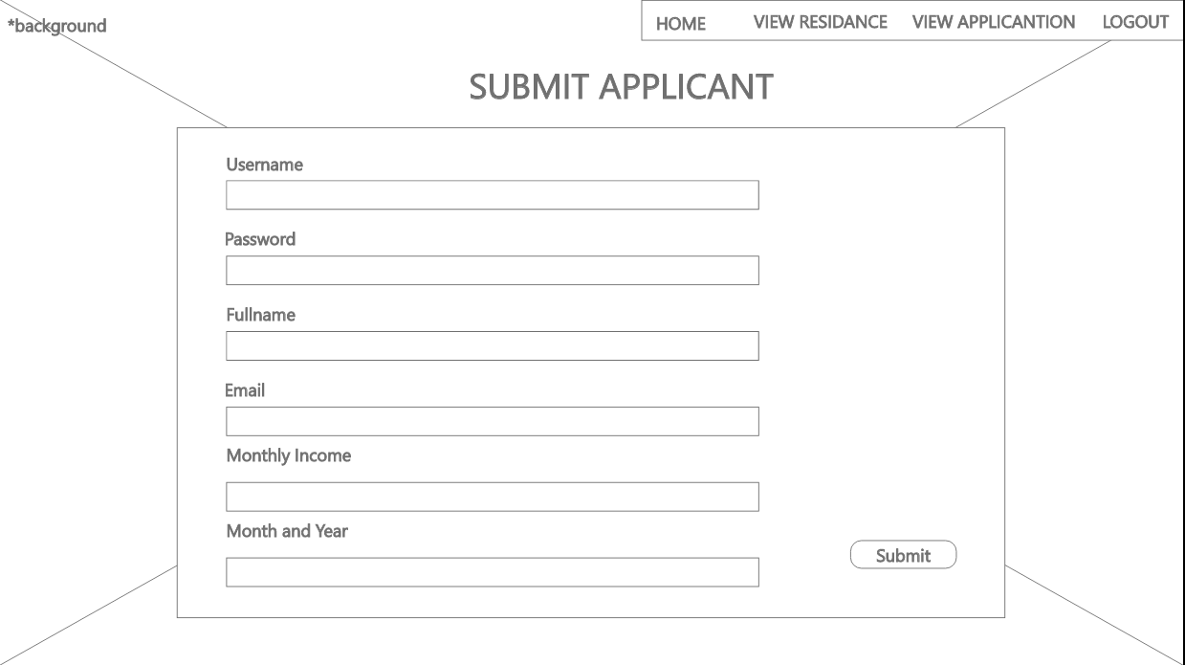

1. **View Applications Page**

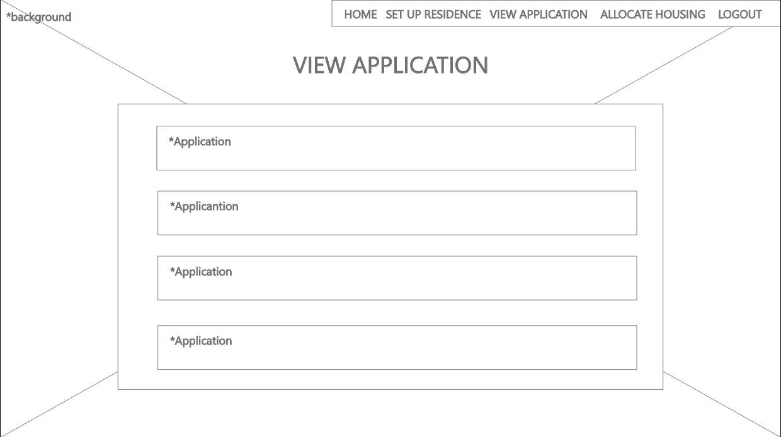

1. **Allocate Housing Page**

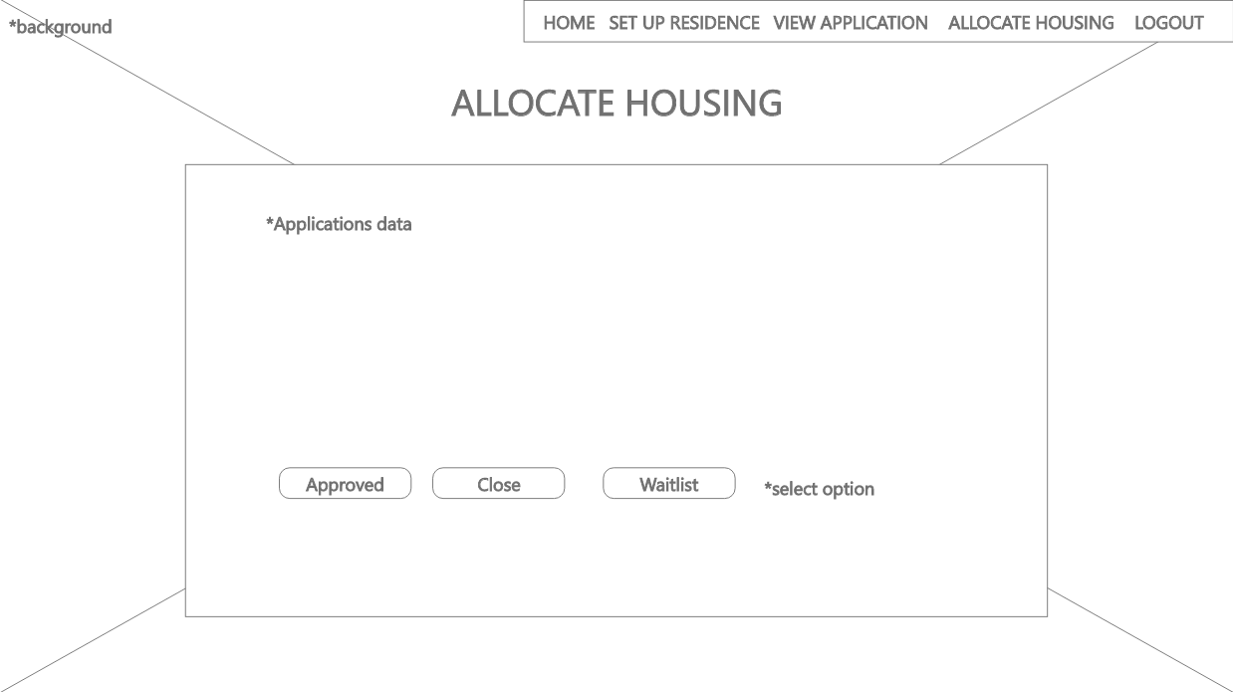

**System Sequence Diagram + Contracts**

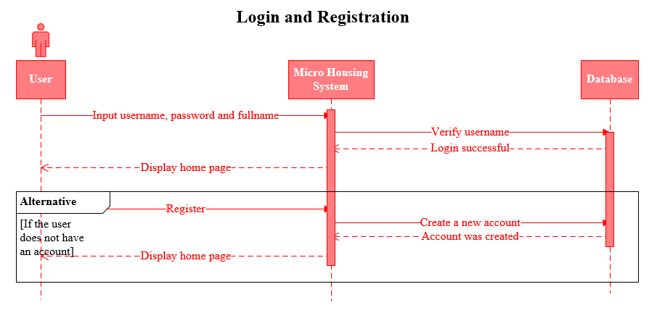

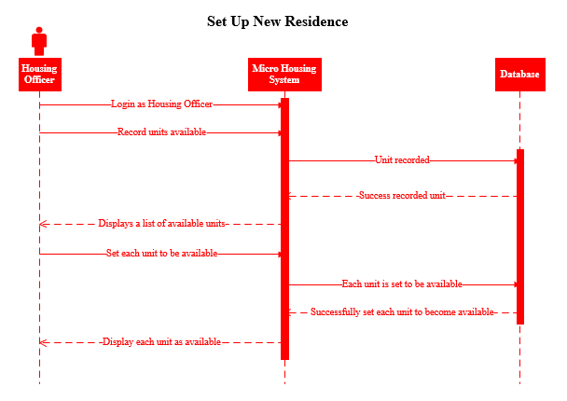

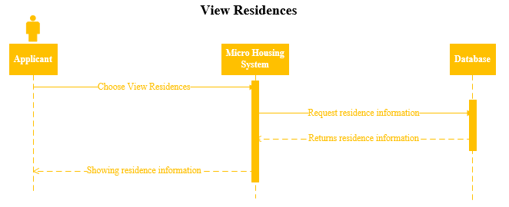

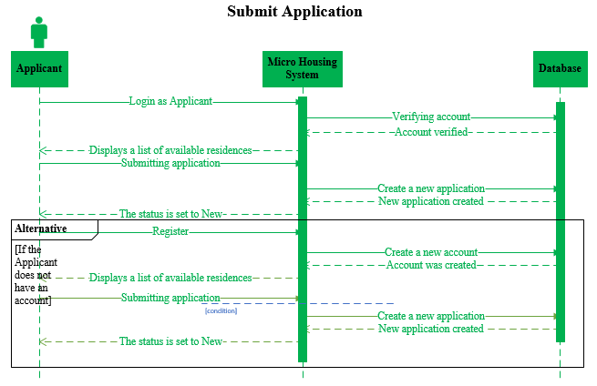

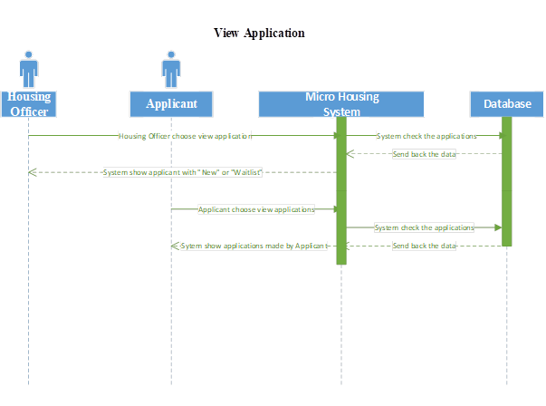



**Contracts**

**Login and Registration – Prepared by Bagus and Wahyudi**

|  |  |  |  |
| --- | --- | --- | --- |
| Operation | Cross Reference | Precondition | Post condition |
| login() | Use Case – Login and Registration | The user wants to enter the website. | The home page is displayed. |
| register() | Use Case – Login and Registration | The user wants to enter the website. | The home page is displayed. |

**Set Up New Residence – Prepared by Bagus**

|  |  |  |  |
| --- | --- | --- | --- |
| Operation | Cross Reference | Precondition | Post condition |
| recordUnitsAvailable() | Use Case – Set Up New Residence | Housing Officer want to record the number and information of each available unit. | A list of available units is displayed. |
| setUnitAvailable() | Use Case – Set Up New Residence | Housing Officer want to set the availability of each unit to be "available". | The availability of each unit is displayed as "available". |

**View Residences – Prepared by Bagus**

|  |  |  |  |
| --- | --- | --- | --- |
| **Operation** | **Cross Reference** | **Precondition** | **Post condition** |
| chooseViewResidences() | Use Case – View Residences | Applicant wants to see information about available housing. | Residence information is displayed. |

**Submit Application – Prepared by Bagus**

|  |  |  |  |
| --- | --- | --- | --- |
| **Operation** | **Cross Reference** | **Precondition** | **Post condition** |
| applicantLogin() | Use Case – Submit Application | Applicant wants to submit an application for a unit. | Displays a list of available residences. |
| submittingApplication() | Use Case – Submit Application | Applicant wants to send the application after choosing a residence. | The status is set to "New". |
| register() | Use Case – Submit Application | Applicant wants to submit an application for a unit. | Displays a list of available residences. |

**View Application – prepared by Wahyudi**

|  |  |  |  |
| --- | --- | --- | --- |
| **Operation** | **Cross Reference** | **Precondition** | **Post condition** |
| chooseViewApplication() | Use Case – choose view application | Housing Officer want to view application | Displays application with status “New” and “Waitlist” |
| viewApplication() | Use Case – view application | Applicant want to view the application | Display application |

**Allocating Housing – prepared by Wahyudi**

|  |  |  |  |
| --- | --- | --- | --- |
| **Operation** | **Cross Reference** | **Precondition** | **Post condition** |
| allocateHousing() | Use Case – select Applicant to allocate Housing | Housing Officer allocate data and already selected | Showing the data to Housing Officer |
| allocateHousing() | Use Case – select Applicant to allocate Housing (alternative) | Housing Officer allocate data and already selected | The Housing Officer does not use the data because it is not eligible |

**Database Design (Data Dictionary)**

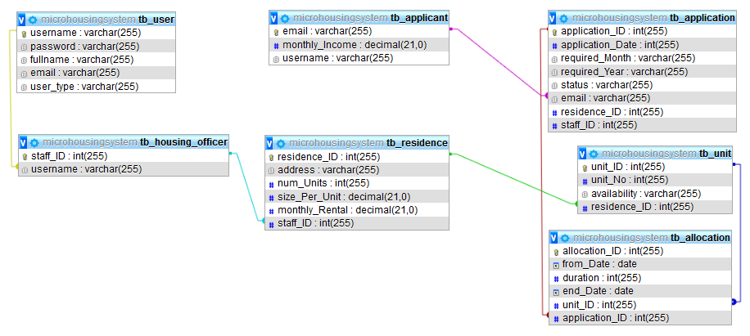

**Identification of The Use Cases to be Developed by Member**

|  |  |
| --- | --- |
| **Use Case** | **Team Member** |
| Login and Registration | Bagus and Wahyudi |
| Home Page | Bagus and Wahyudi |
| Set up New Residence | Bagus |
| View Residence | Bagus |
| Submit Application | Bagus and Wahyudi |
| View Application | Wahyudi |
| Allocating Housing | Wahyudi |

**Test Objectives**

The objectives of this test is to check whether the website is running normally and in accordance with the use case. We also check the website so that its function works well and ensure that the user interface is easy to use.

**Test Plan & Method & Automated Testing Tool**

In this test we are going to test the login and register page, first we are going to input the username, password, Fullname, and Email then register as Applicant or Housing Officer. After registered then we need to login by input the username, password, and choose the User Type that you already created. We are using Selenium testing tool to test the website to make sure that there is no error or bug in the website.

**Test Cases**

* **Unit and Integration Testing**

We are using the Selenium program to test the code:

1. Set Up New Residence + Set Up New Residence Form

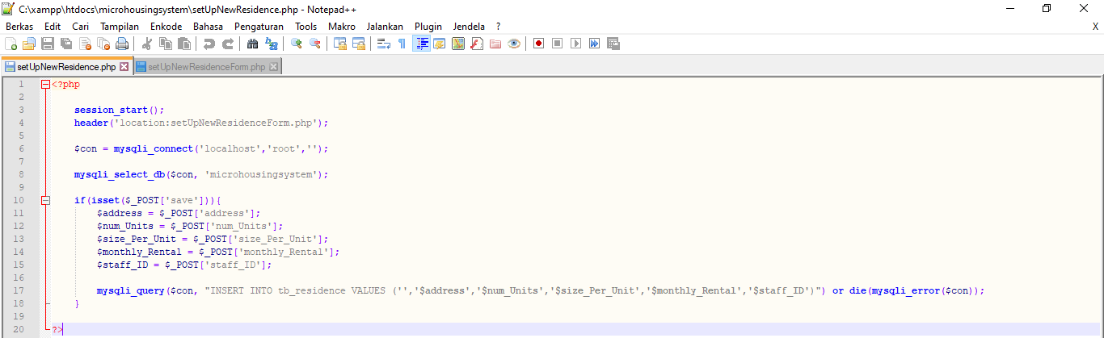

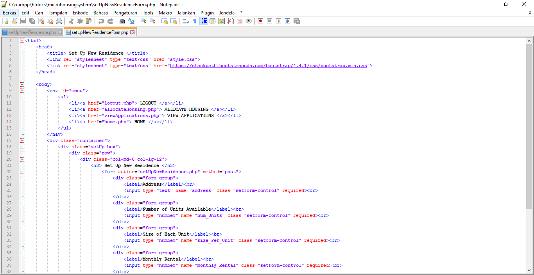

Selenium Test Result:

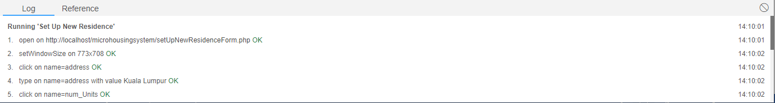

1. View Residences + View Residences Form

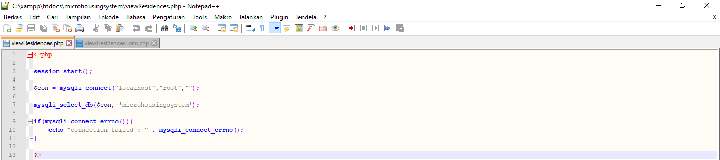

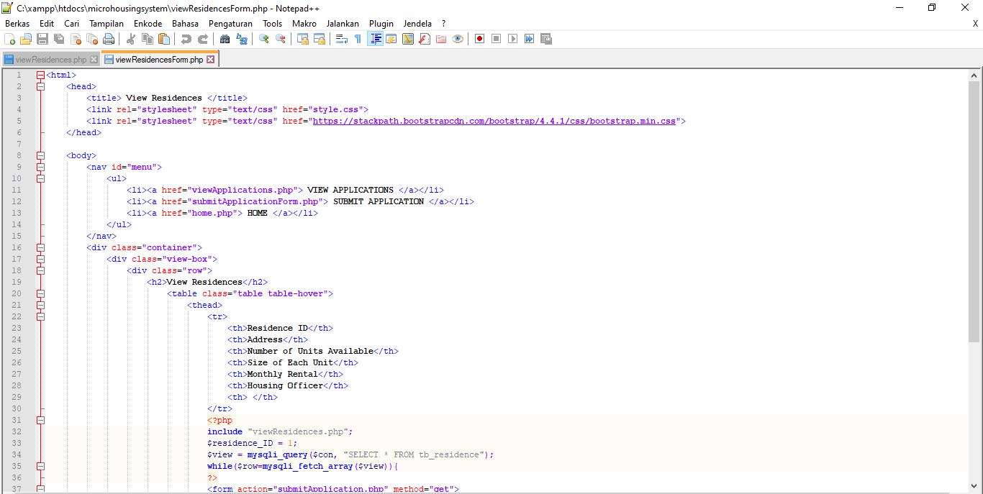

Selenium Test Result:

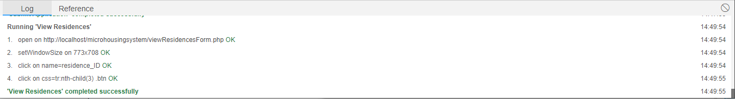

1. Submit Application + Submit Application Form

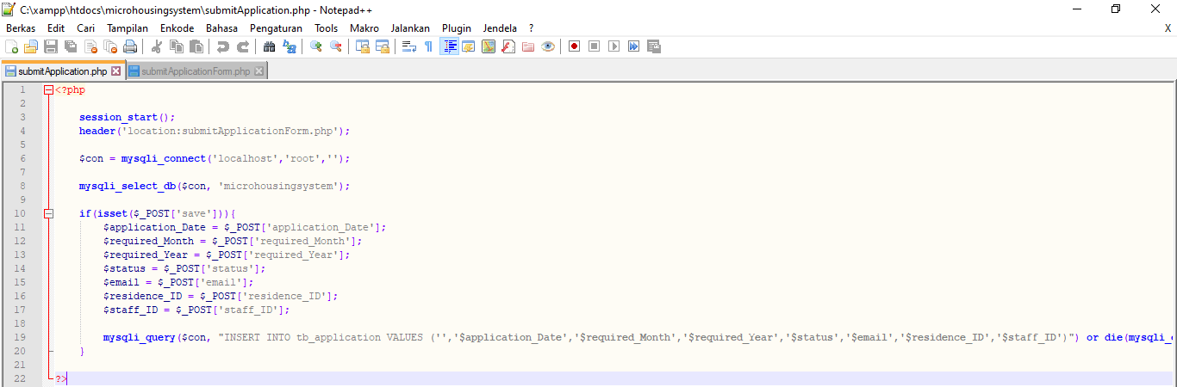

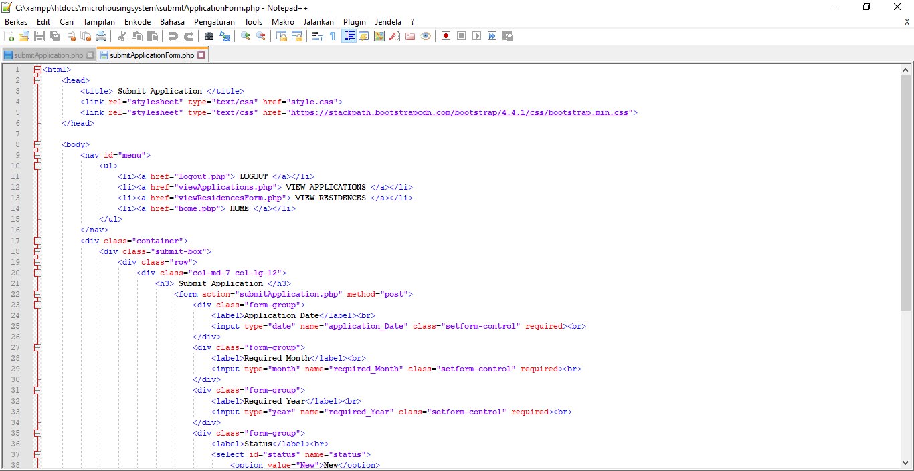

Selenium Test Result:

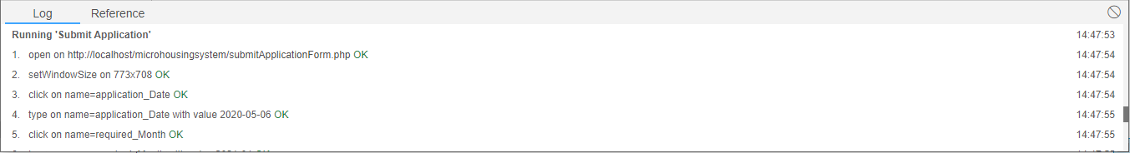

1. View Application Housing and Applicant + View Application Housing Officer and Applicant Form

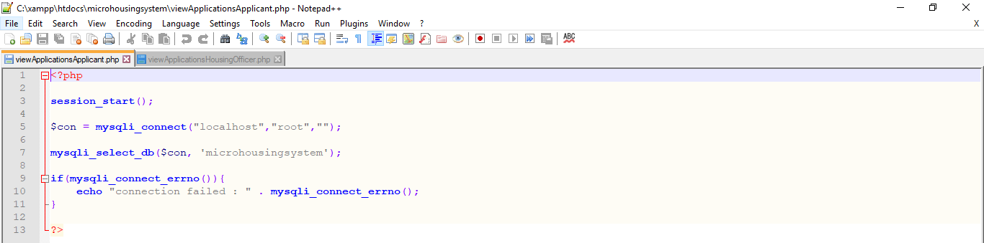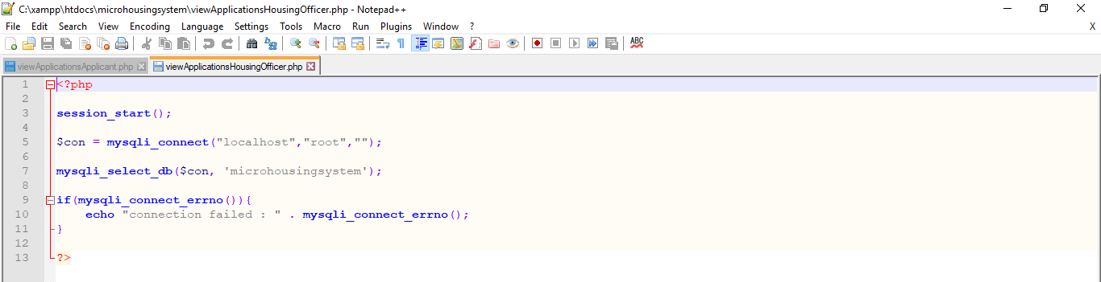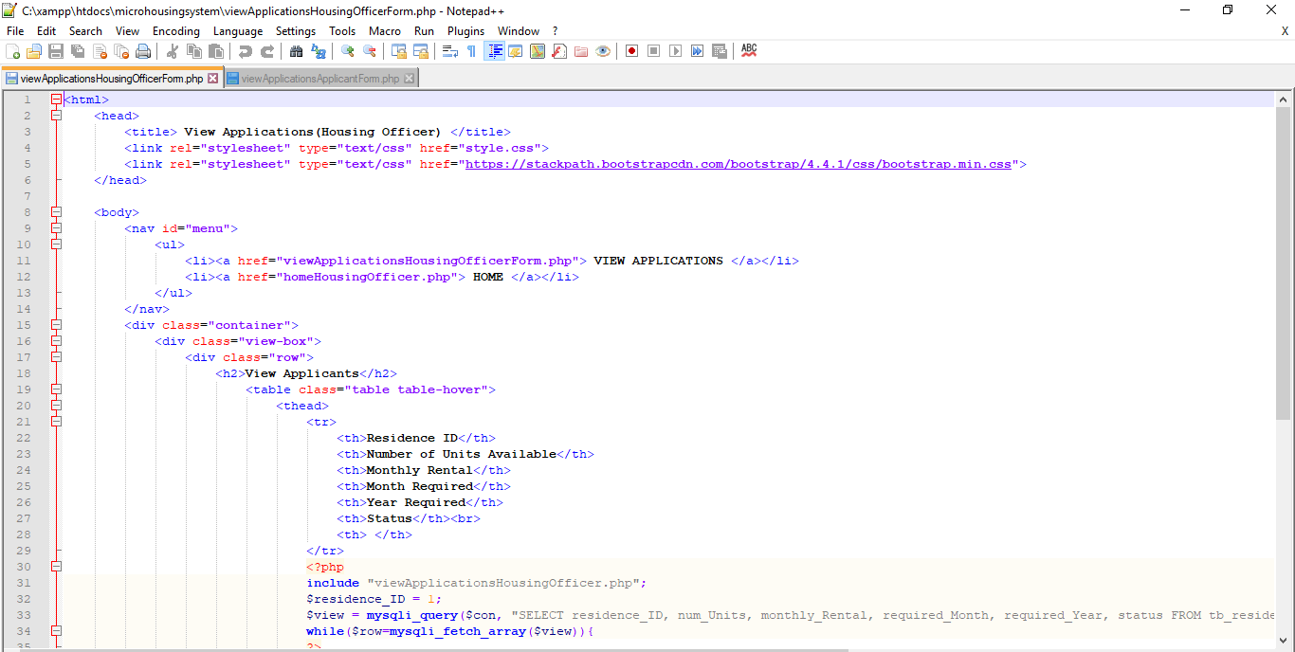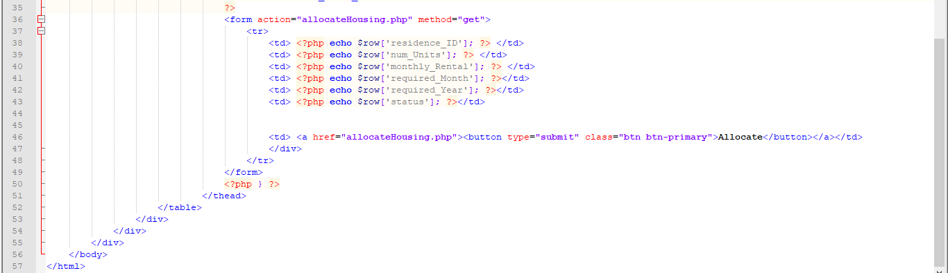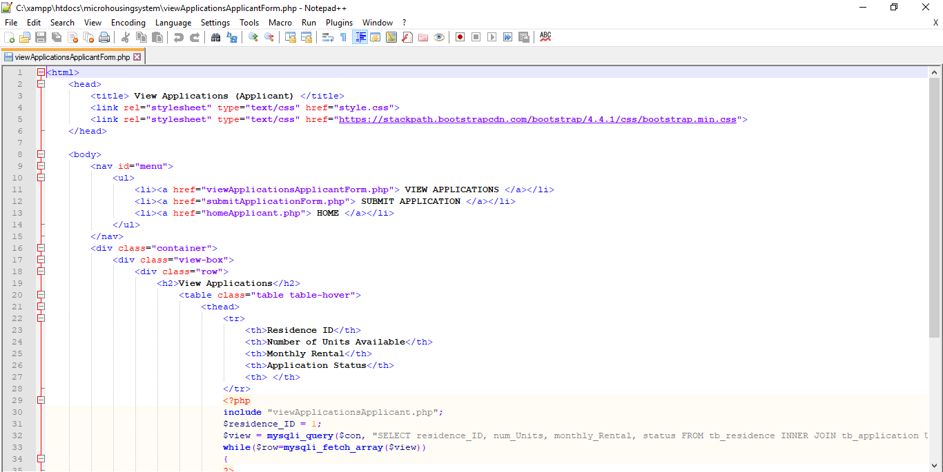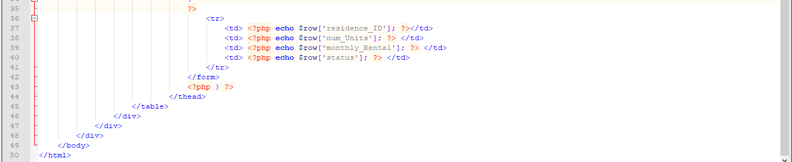

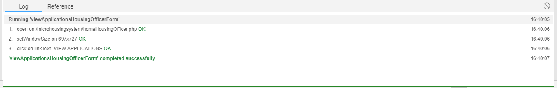Selenium Test Result

1. Allocate Housing and Update + View Allocate Housing Form and View Allocate Housing

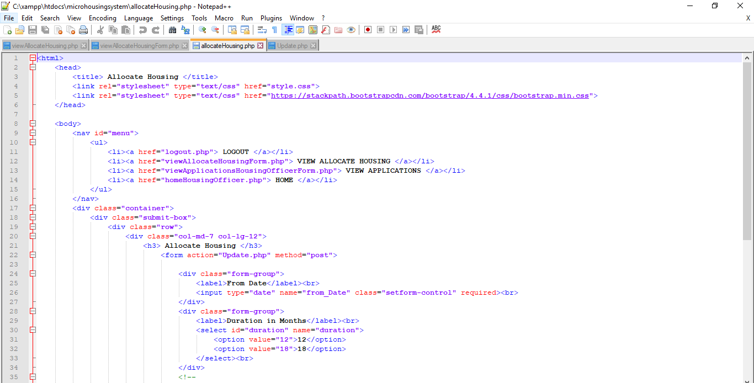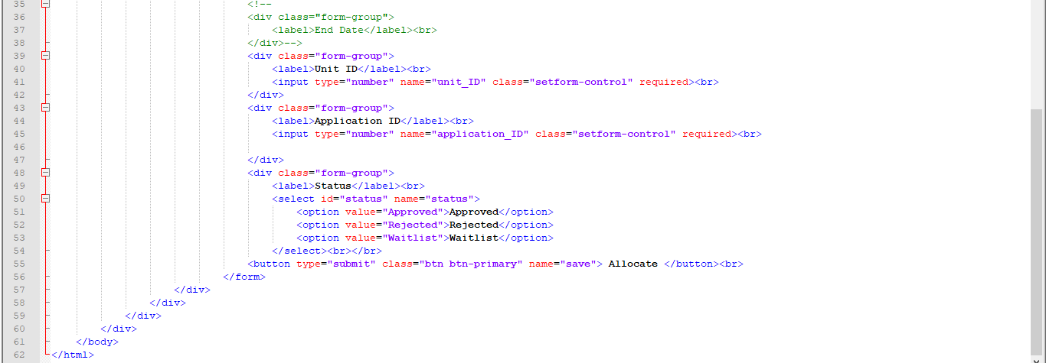

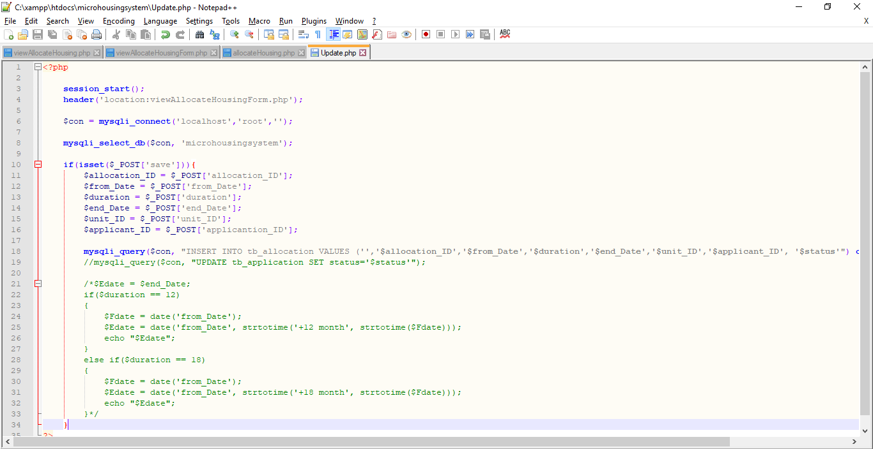

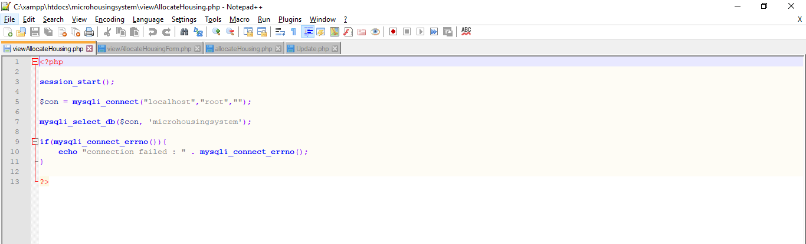

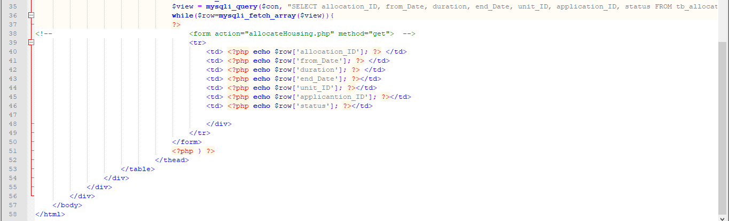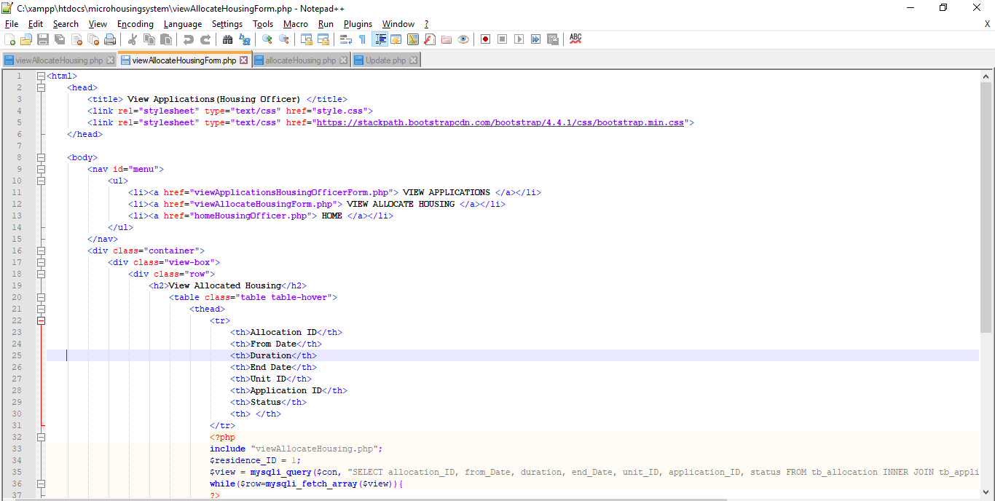

Selenium

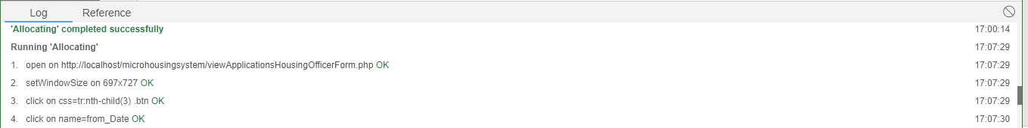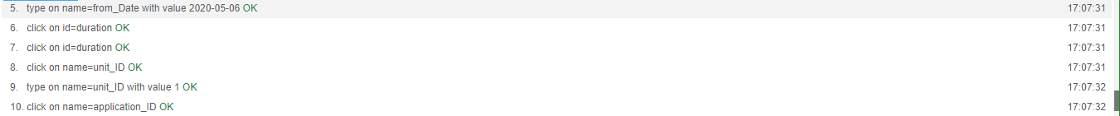

* **System Testing**

**Manual Testing**

1. 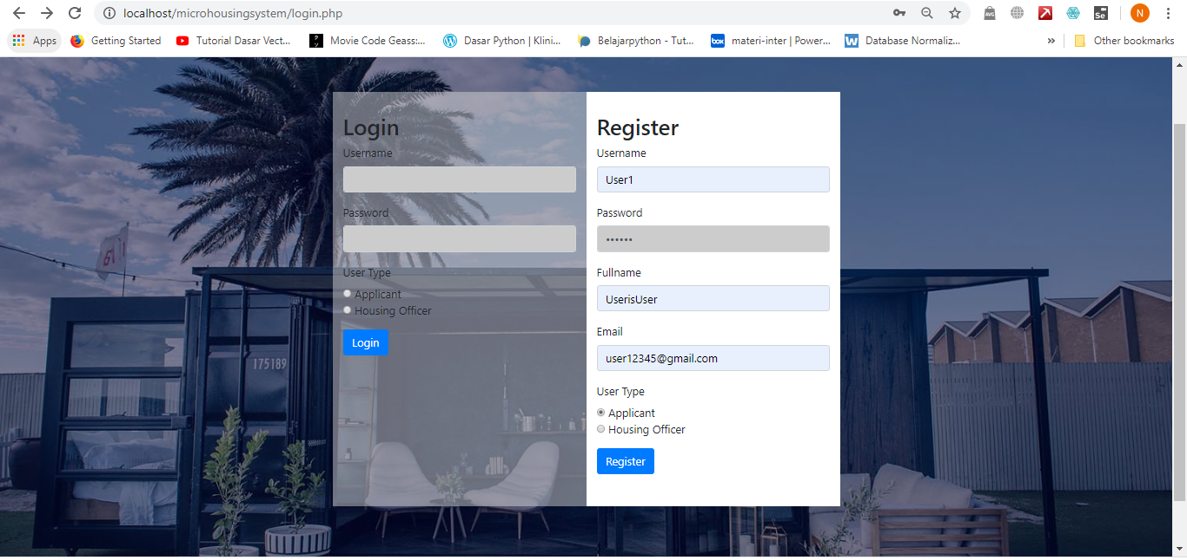Input Username, Password, Fullname, Email, and chose User Type then Click Register to Register

1. 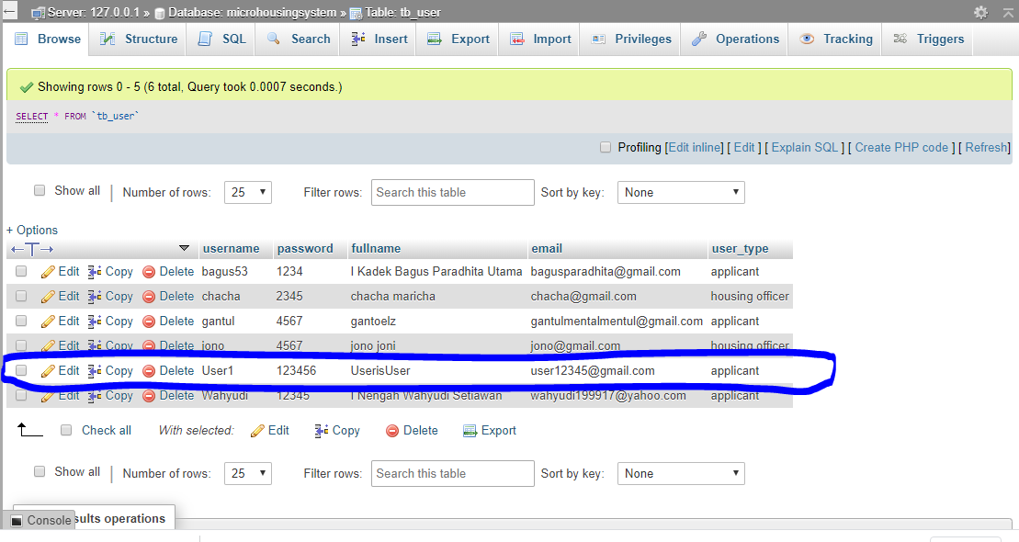After that the data will be automatically stored in the database
2. 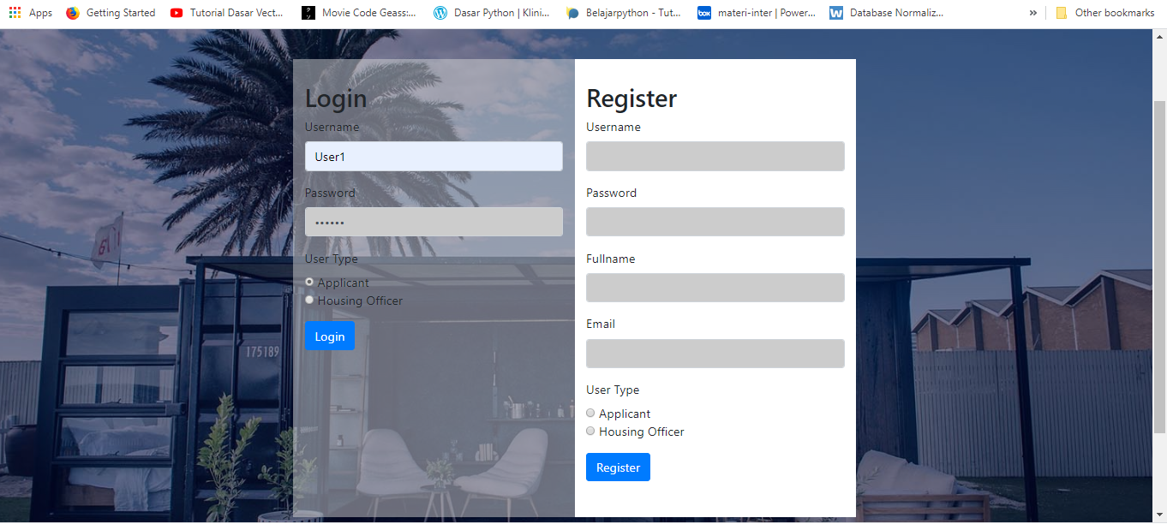Next input your registered Username, Password, and the User Type then click Login
3. Welcome to the Home page then click LOGOUT to go back to Login and Registration page

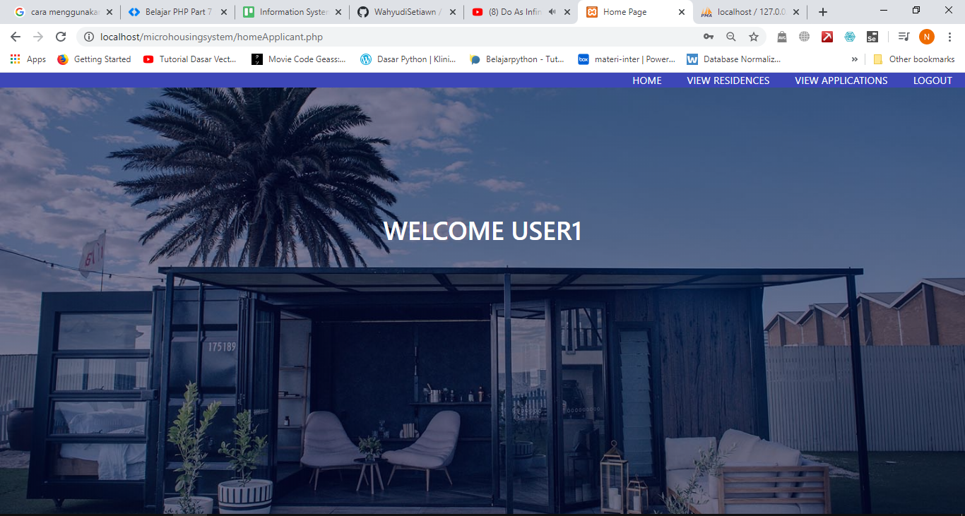

1. Click View Residences to view the available residences and The Applicant can Submit Application to the residence by click the Submit Application button

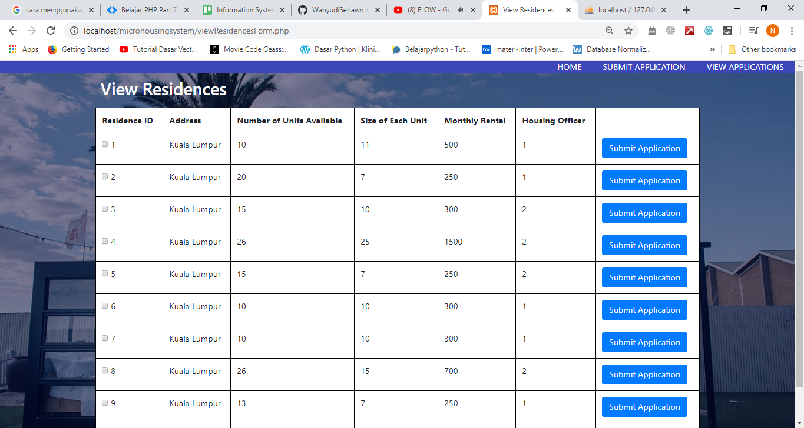

1. 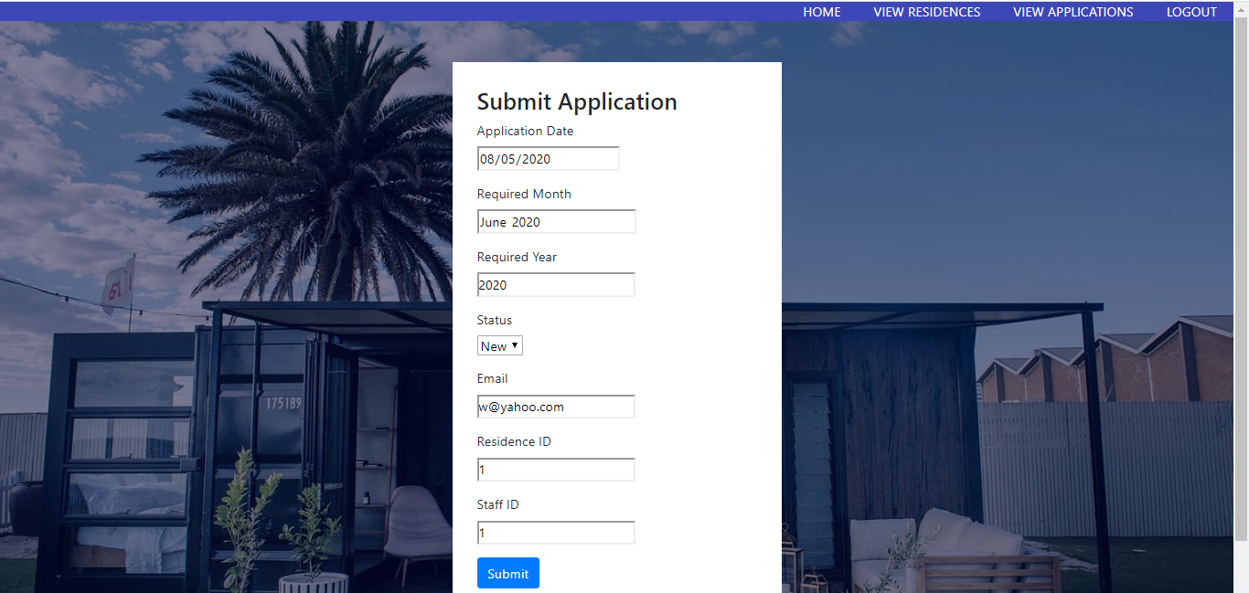After click the Submit Application button then the Applicant will move to Submit Application page. Applicant can submit the application by input the Application Date, Required Month, Required Year, Status, Email, Residence ID, and Staff ID then click Submit button to submit the application.
2. After that the data will be stored to the database

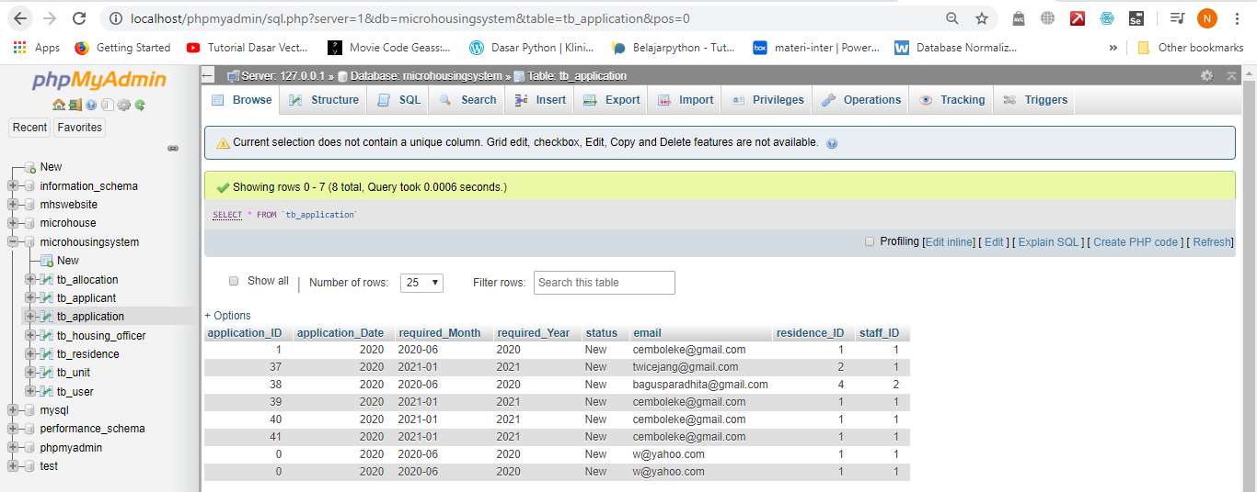

1. 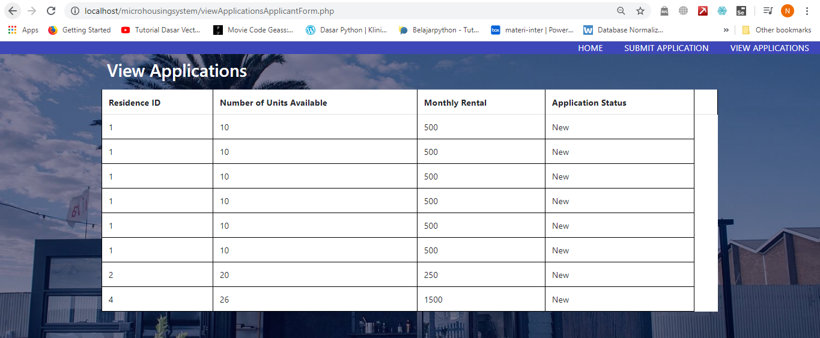The Applicant can view the applicant in the View Applications
2. 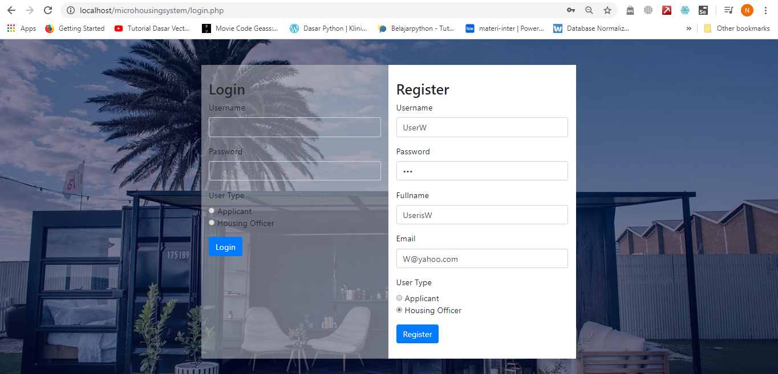Input Username, Password, Fullname, Email, and choose Housing Officer User Type then Click Register to Register
3. After that the data will be stored in the database

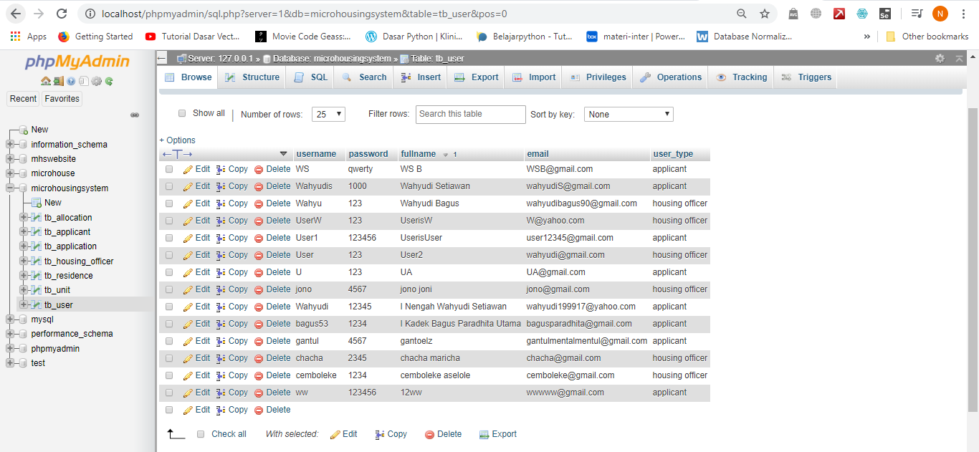

1. 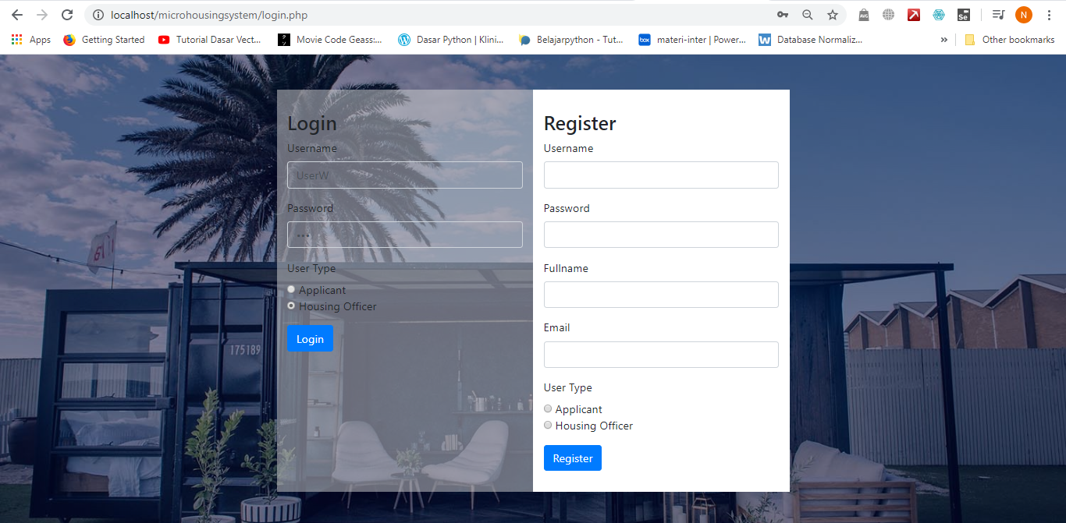Next input the Username, Password, choose the User Type as Housing Officer, and click Login button
2. Click LOGOUT to go back to Login and Registration page

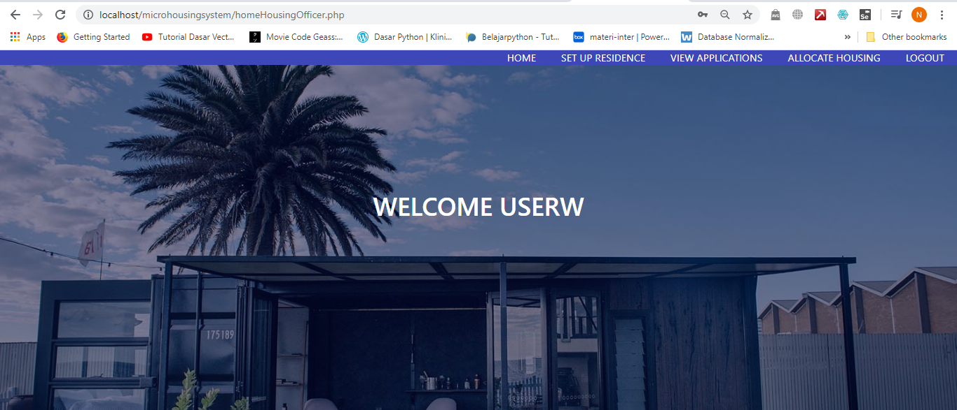

1. Then Click SET UP RESIDENCE to make a new residence by input Address, Number of Unit Available, Size of Each Unit, Monthly Rental, and Housing Officer ID, then click Submit button to submit the new Residence

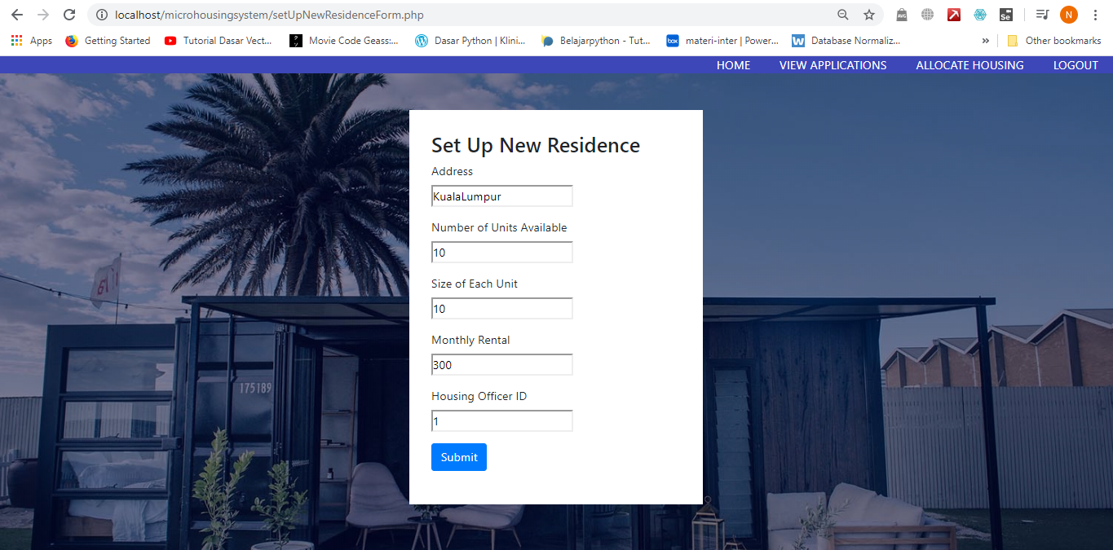

1. 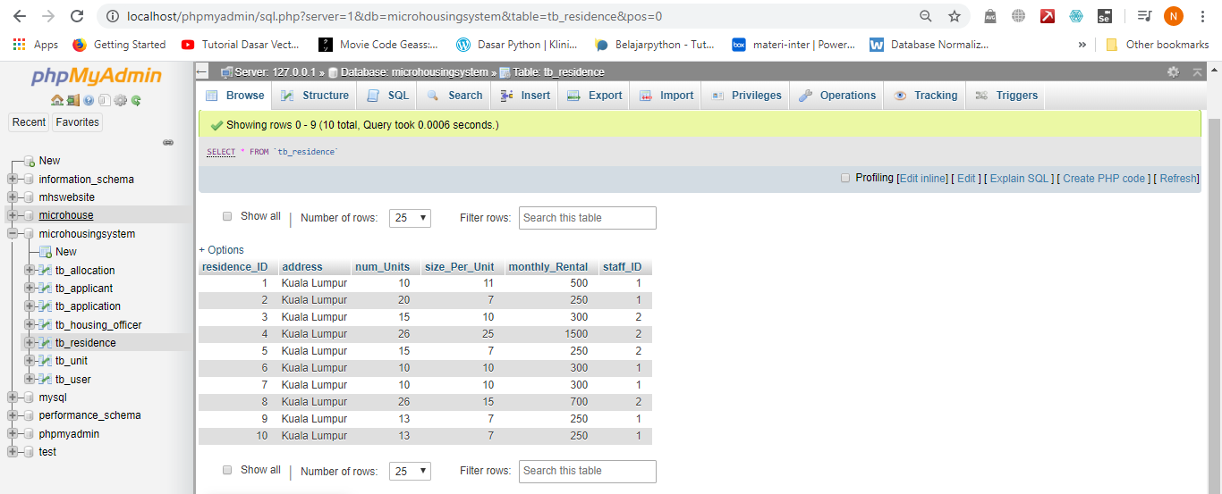The data is stored in the database
2. 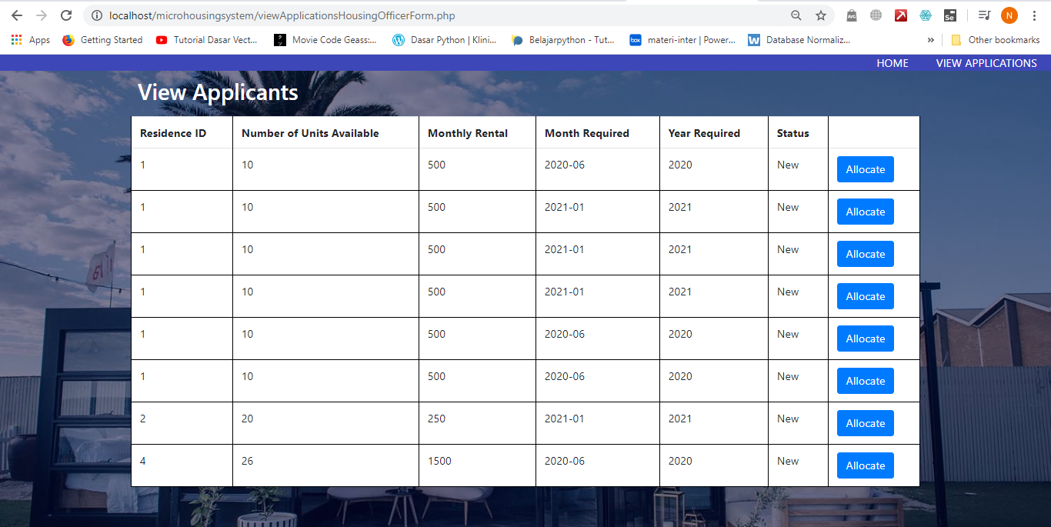Then click VIEW APPLICATIONS to view application and click Allocate button to allocate the applicant
3. 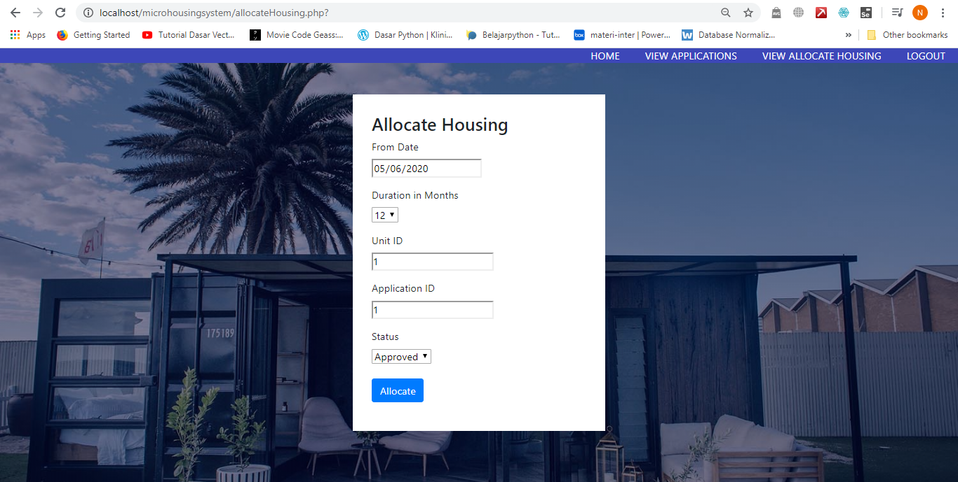Input From Date, Duration in Months, Unit ID, Application ID, and Status then click Submit button to allocate housing
4. 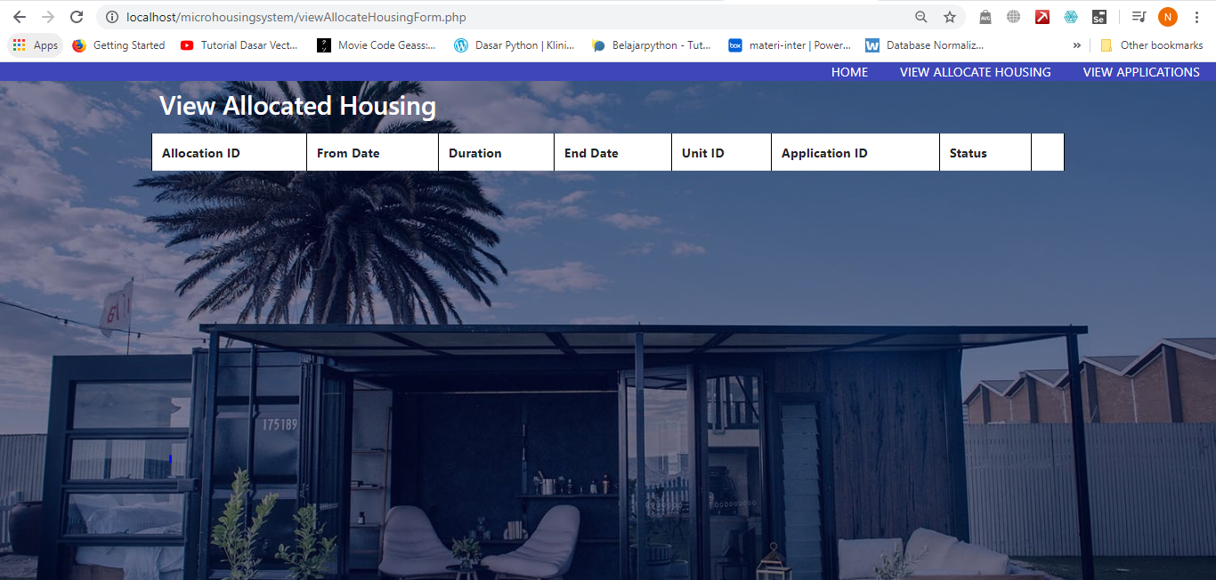Next the Housing Officer can see the Allocated Housing in View Allocate Housing

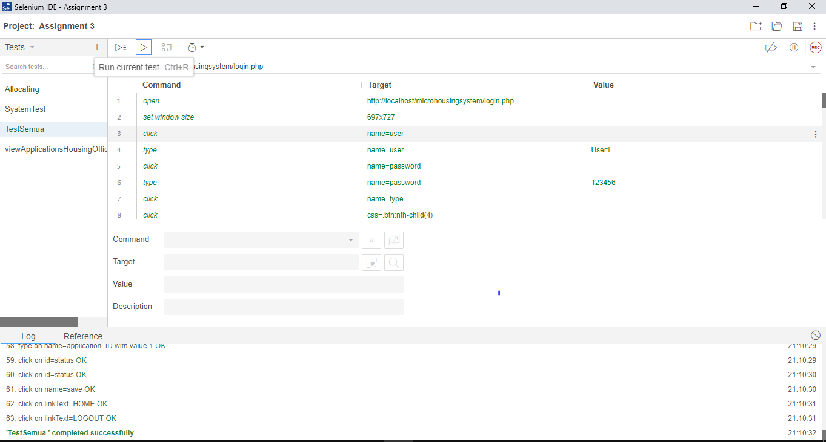**Selenium Test**

**Test Analysis Report**

The conclusion after testing, there was no error when we did the selenium test but when we did the test manually, we found some errors such as a web page that cannot connect to the database and the data did not appear on the page that it should. After having done both selenium and manual tests, we can see that this system does not meet the objectives because the web pages and systems do not function properly but in terms of UI the web has a simple and easy to use UI.

**Conclusion/Review – Prepared by I Kadek Bagus Paradhita Utama**

**Did the group meet the objectives defined in Assignment 1?**

While working on this Information System Project for Micro Housing, we faced many challenges and difficulties caused by our lack of skills in implementing this kind of project. This is made worse by the spread of the corona virus (COVID-19) which makes it difficult for us to coordinate to complete projects. However, fortunately we are still able to meet the objectives specified in assignment 1, namely, developing information systems that can help young people to find affordable housing in DBKL micro housing facilities by informing the location of the house, rental prices, and rental dates expire.

**What went wrong and what went right?**

What went wrong in working on this project is, it's very difficult in allocating our time to be able to complete the project, because the world situation is facing coronavirus (COVID-19) so we have difficulty in coordination and although we can communicate online, but because of the busyness we have to do at home, like helping families with economic problems, so often we only have time at night to do the assignment, I personally have to do the assignment until the wee hours of the morning and this makes my body's metabolism disturbed, when in fact the government has appealed so that people are not too stressed at times like this, because if the immune system declines, it can be fatal if the person is infected with COVID-19. Not to mention if my team partner is not cooperative, so it's difficult to do this assignment, so I realize that our project results are not optimal.

What went right about this assignment is that at least the group succeeded in meeting the objectives specified in assignment 1, where the objective was to develop an information system that could help young people to find affordable housing in DBKL micro housing facilities by informing the location of the house, rental prices, and the rental date ends.

**What you would have done differently?**

What I will do differently is that I personally want to improve the appearance of the web pages that I make or the user interface and its functions so that it can be more easily navigated by the user, as well as providing a more memorable web usage experience.

**Conclusion/Review-Prepared by I Nengah Wahyudi Setiawan**

**Did the group meet the objectives defined in Assignment 1?**

Yes, we did. Luckily, we managed to meet the objectives defined in Assignment 1 such as developing Information System that can help the young people to find an affordable housing in DBKL micro housing facilities by informing the rental prices, micro house location, and when the rental date will be expired.

**What went wrong and what went right?**

What went wrong:

It is very difficult to allocate our time to working and finish the project because the Covid-19 or Corona virus that have been spread across the globe that limit us to meet face to face. Although we can still use online communication even though It not as effective as meeting face to face. It is my first time to make a php based website and it make me feeling stress because I only have a little time to studying php from scratch. We helping our family to improve the economy in this kind of situation.

What went right:

We can at least full fill the objective in Assignment 1 to help young people to find an affordable housing in DBKL micro housing facility by informing the rental prices, micro house location, and when the rental date will be expired. We also can make an operational website, even though there are some error with the website likely the coding does not connect to the database and the data does not appear in the view allocate housing.

**What would you have done differently?**

I would like to studying to improve my knowledge in making website to make it user friendly interface and minimize the error. We will make a better time management to balancing between making the project and the other activities

**Update Gantt Chart/Trello Board**

1. **Update Gantt Chart**

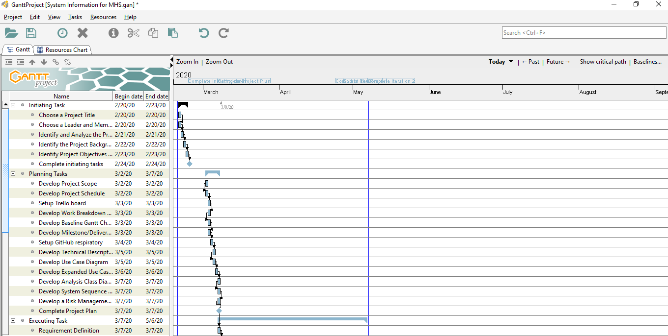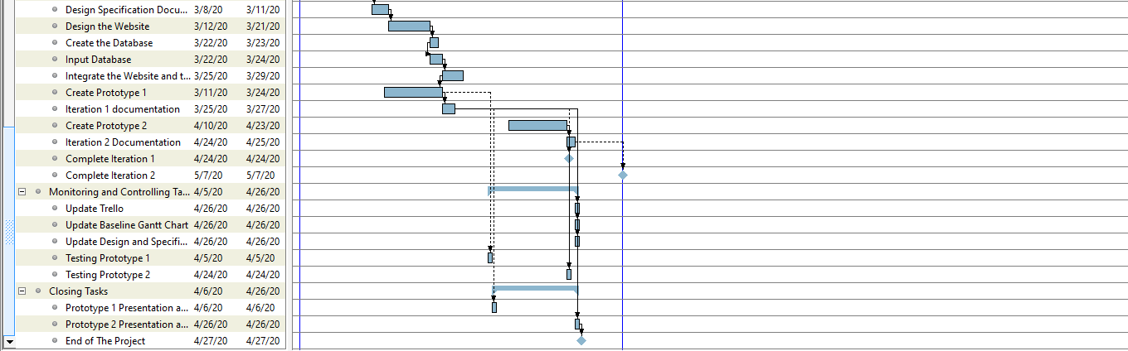

1. 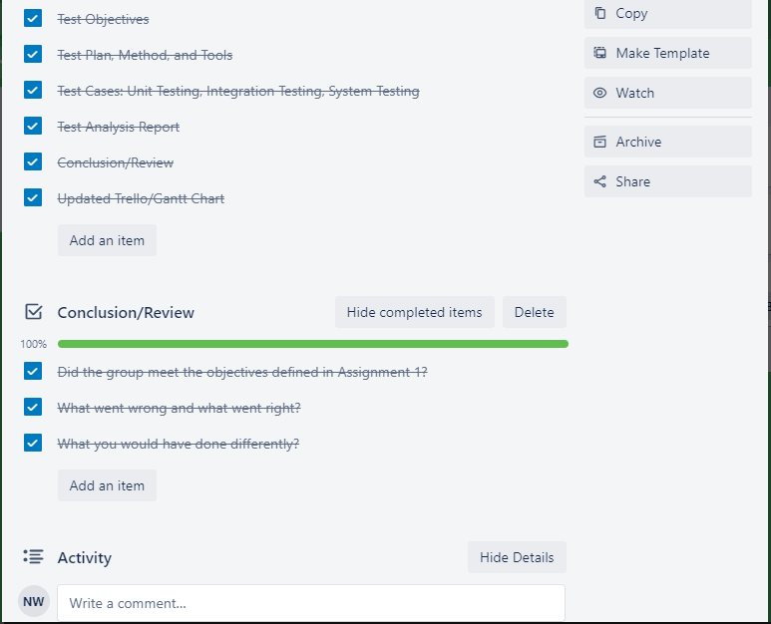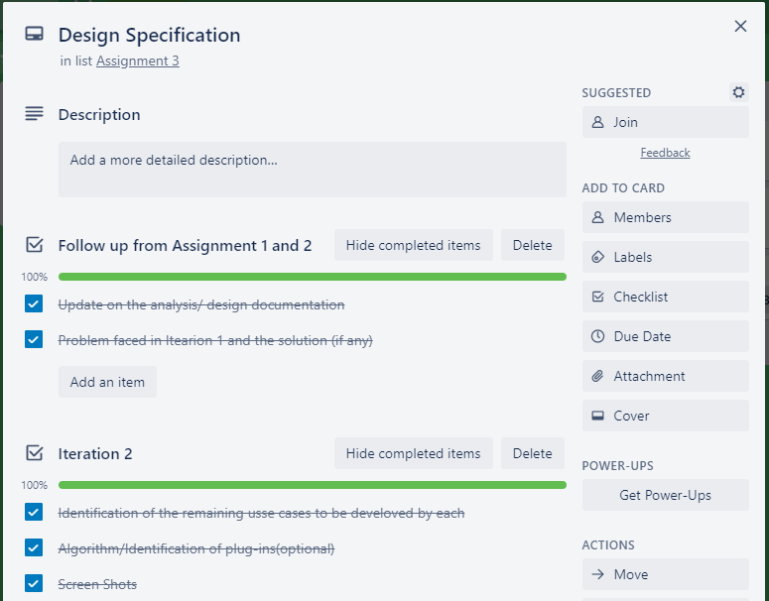**Update Trello Board**

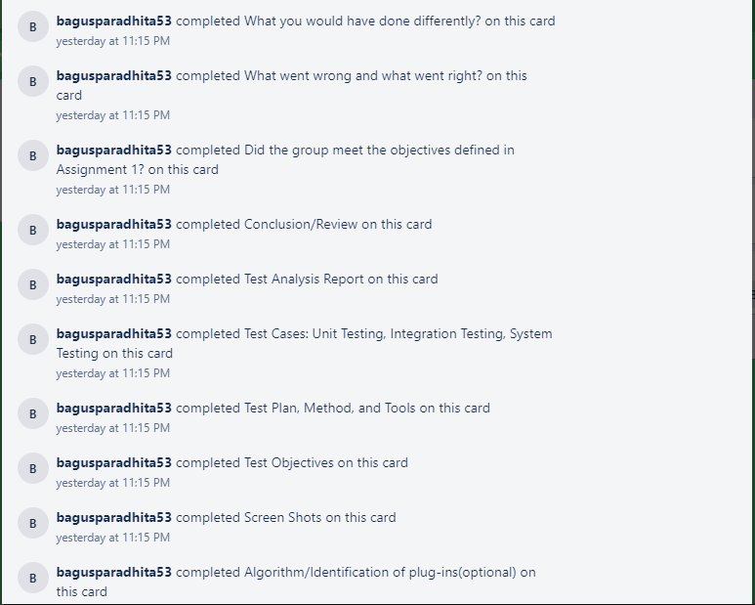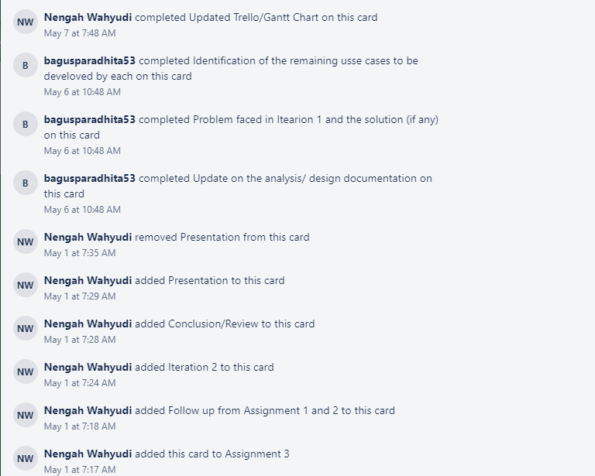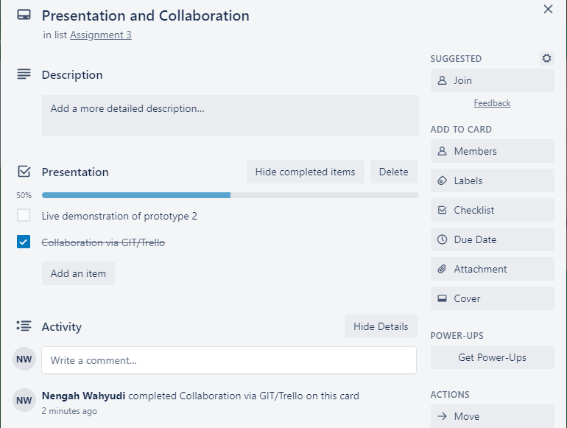

**GitHub**

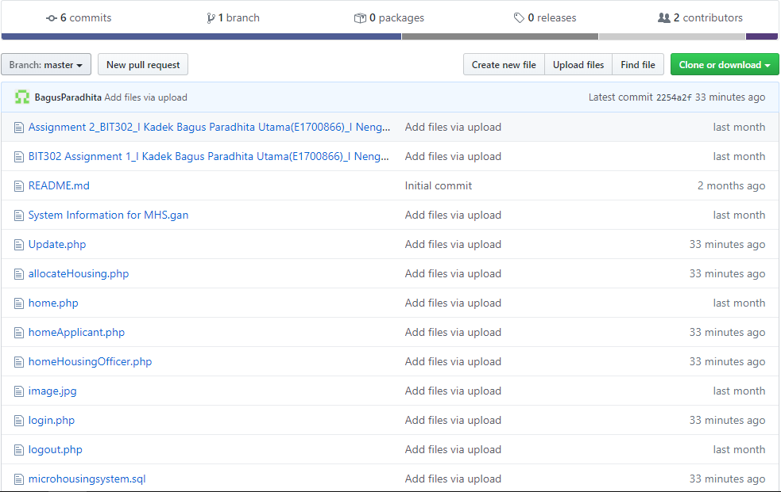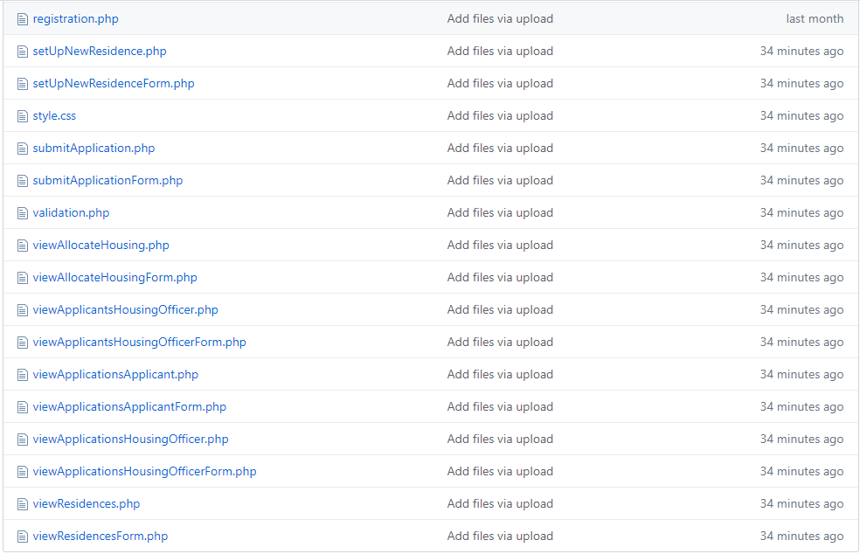

**Reference**

Hadi, D. A., & Hadi, D. A. (2018, October 14). Membuat Login Multi User Level Dengan PHP dan MySQLi. Retrieved from <https://www.malasngoding.com/membuat-login-multi-user-level-dengan-php-dan-mysqli/>

Hadi, D. A., & Hadi, D. A. (2018, March 15). Membuat CRUD Dengan PHP dan MySQLi - Update Data. Retrieved from <https://www.malasngoding.com/membuat-crud-dengan-php-dan-mysqli-update-data/>

Hadi, D. A., & Hadi, D. A. (2018, March 15). Membuat CRUD Dengan PHP dan MySQLi - Input Data. Retrieved from <https://www.malasngoding.com/membuat-crud-dengan-php-dan-mysqli-input-data/>